PATRIOT HALL
Lauren P. BOOTH &
Rembert meeting room RENTAL INFORMATION
PACKET

Sumter County Cultural Center
135 Haynsworth Street
Sumter, SC 29150
(803) 436-2260
patriothall@sumtercountysc.gov

Office Hours:
M-F 8:30am – 5:00pm

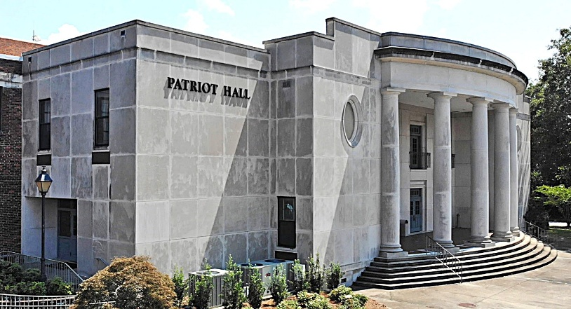
LAUREN P. BOOTH ROOM / MEETING ROOM RENTAL INFORMATION
135 Haynsworth Street
Sumter, SC 29150
(803) 436-2260
patriothall@sumtercountysc.gov

All rates are effective May 1, 2025, and are subject to change without notice.

REQUESTED RENTAL DATE: __________________________________
Please check the desired event space:

☐ LAUREN P. BOOTH ROOM ☐ SUMTER GALLERY OF ART ☐ REMBERT MEETING ROOM

PAYER/LEASING ORGANIZATION ☐ Check here if different than Payer/Leasing Organization

First Name___________________________________ Last Name___________________________________________
Address ___________________________________________________________________________________________
City/State________________________________________________ Zip______________________________________
Phone ________________________________ Email_______________________________________________________

TYPE OF EVENT / PROGRAM. Give full details of intended use of the room:

Date: ___________________________________________ Time: ___________________________________________
Arrival Time:___________________ Departure Time:________________ Number of Attendees: _______________
Event Type: ________________________________________________________________________________________
RENTAL FEES

BOOTH ROOM & SUMTER GALLERY OF ART

- $525 (6 continuous hours).
- Additional hours: $112/ea.
- Holiday Rental: $700 (6 continuous hours). - Additional hours: $125/ea.
- Tables and chairs are included.
- Charges for place settings, linens, etc. may not be known until the day of the reception.
- Linen fees (if desired): $20/per tablecloth; $4/per dinner napkin.
- The lobby is available for small weddings when rented with the Lauren P. Booth Reception Room. Additional cost: $200.
- Booth Room seating capacity: 80
- For weddings: Bird seed must be used in lieu of rice only on the outside of the facility in paved or sidewalk areas.

REMBERT MEETING ROOM

- $30/hr. Monday-Friday 8:30 a.m. to 5:00 p.m.
- $42/hr. weekends & weekdays after 5:00 p.m.
- Projector & screen: Additional cost: $100.

DEPOSIT

Before a date can be held on the calendar, the following is required:

A completed and signed rental contract and deposit of 50% of the base rental fee. The balance is due two (2) weeks before the event. If the contract and payment are not received within two (2) weeks, your request will be considered null and void and removed from Patriot Hall events schedule. Out of state checks are not accepted. Deposits can be made by credit card, money order, check, or cash. Do not mail cash.
INITIAL HERE ______________

CATERING INFORMATION

Only licensed caterers are allowed to serve food in the Lauren Booth reception area. Please ask caterer(s) to contact Patriot Hall one (1) week prior to your event to plan for table layout and items needed. Please provide contact information for the caterer servicing your event. INITIAL HERE __________________

Business Name____________________________________________________________________________________
First Name___________________________________ Last Name__________________________________________
Address ____________________________________________ City/State/Zip _________________________________
Phone __________________________________ Email_____________________________________________________

EVENT STAFFING

All Patriot Hall events require Patriot Hall personnel which are compensated by Sumter County Government.

POLICE SECURITY REQUIREMENTS

Patriot Hall reserves the right to require fire, police, or other security personnel for events. The need shall be determined based on the type of event and the anticipated crowd. One (1) Security Officer is required for all Patriot Hall events at the rate of $44/hr per officer with a 4-hour minimum. This fee must be included with the rental fee. Lessee is required to provide safety/security personnel during the lease period at Lessee’s expense. Safety/security personnel must be off-duty uniformed Sumter County Sheriff Deputies and must be onsite one (1) hour before the start of event until at least one (1) hour afterwards. Patriot Hall reserves the right to decide if additional officers are needed. INITIAL HERE __________

BUILDING OPERATING POLICIES

- All charges associated with damages to the Patriot Hall facility, equipment, furnishings, replacement, repair, cleaning, restoring, etc. resulting from misuse, carelessness, or from failure to provide adequate security personnel will be charged to Lessee.
- Lessee is responsible for restoring the facility, furnishings, equipment, etc. to the same condition in which Lessee received them and assumes full responsibility for damage to or loss of Lessor’s property.
- Accoutrements shall be washed, and trash removed and placed in receptacles provided.
- Table surfaces shall be protected from damages of any kind or remedied at Lessee's expense.
- Beverages shall be consumed on the premises and only within the facility. No beverage or food is permitted in the carpeted lobby areas or auditorium.
- Under no circumstances may decorations be tacked, taped, stapled, or attached to walls, woodwork, furniture, ceiling, floors, windows, doors, lighting fixtures, etc.
- All carpet and furniture located along the perimeter of the room are not allowed to be moved. Only Patriot Hall staff may move or remove furnishing from assigned areas.
- Helium balloons are not permitted in the meeting room areas. INITIAL HERE ________________

I have read, understand, and agree to comply with all policies, rules, deadlines, and rental fees specified in this rental contract.

Signature __________________________________________________ Date_____________________________

Print Name_________________________________________________

