PATRIOT HALL
Business & nonprofit
AUDITORIUM RENTAL
INFORMATION PACKET

Sumter County Cultural Center
135 Haynsworth Street
Sumter, SC 29150
(803) 436-2260
patriothall@sumtercountysc.gov

Office Hours:
M-F 8:30am – 5:00pm

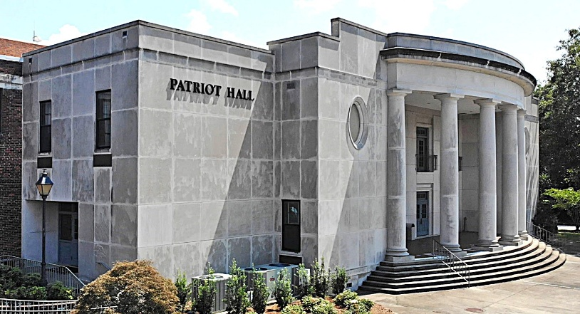

PATRIOT HALL AUDITORIUM RENTAL INFORMATION
135 Haynsworth Street
Sumter, SC 29150
(803) 436-2260
patriothall@sumtercountysc.gov

All rates are effective May 1, 2025, and are subject to change without notice.

REQUESTED RENTAL DATE:___________________________________________________________________________

PAYER/LEASING ORGANIZATION ☐ Check here if different than Payer/Leasing Organization

First Name___________________________________ Last Name_____________________________________________
Address ____________________________________________ City/State/Zip ____________________________________
Phone __________________________________ Email _______________________________________________________

PLEASE NOTE: Sumter County has the authority to select the type of programming presented inside Patriot Hall Auditorium. Programs containing gratuitous profanity, abusive language, nudity, inappropriate behavior, and events deemed offensive to public morals will not be allowed. It is understood and agreed that the Lessor shall not permit such events to be held upon the premises. If event is offensive to public morals, fails to uphold advertising claims, and violates content restrictions set out herein, such occurrences shall constitute default of this Lease Agreement to permit Lessor to immediately terminate, at Lessor’s option, Lessee’s right to use the subject property without refunding any deposits and without waiving right to enforce payment of amounts due hereunder. INITIAL HERE __________

TYPE OF EVENT / PROGRAM. Give full details of intended use of the auditorium:
_________________________________________________________________________________________________________________
_________________________________________________________________________________________________________________
_________________________________________________________________________________________________________________

TYPE OF BUSINESS

☐ BUSINESS RATE
$2073.00 Base Rental Fee

☐ NON-PROFIT RATE
$1503.00 Base Rental Fee
*Must show proof of Nonprofit Status

Rate includes: Pre-Performance (5 hrs), Rehearsal (3 hrs), Performance (6 hrs). Total: 14 usage hours.

RENTAL FEES
The Patriot Hall rental contract is based on a Four-Wall Policy. The Lessee assumes responsibility for all expenses of a show or event and keeps all revenue.
INITIAL HERE __________

WILL THE BOX OFFICE BE NEEDED?
☐ Yes ☐ No

To be completed by Patriot Hall staff only:

Pre-Performance / Rehearsal Date(s) _____________________________________ Time(s)___________________________________
Performance Date(s) _____________________________________________________ Time(s)___________________________________

YOUR EVENT AGREEMENT INCLUDES:

Access for a total of fourteen (14) usage hours. Any hours over this allotted time may be assessed a fee of $80/hr.

Access to loading dock, corridors, dressing rooms, green rooms, lobby, stage, and audience areas.

At the time an Event Agreement is signed, Lessees are required to submit a deposit, proof of insurance, and proof of non-profit status (if applicable). The contract must be fully executed prior to:

- Ticket sales
- Promotion of the event
- Occupancy of space
- Storage of equipment

DEPOSIT

Before a date can be held on the calendar, the following is required:

A pre-performance consultation with the Technical Director. Please bring a copy of your Technical Rider.

A completed and signed rental contract and deposit of 50% of the base rental fee. The balance is due two (2) weeks before the event. If the contract and payment are not received within two (2) weeks, your request will be considered null and void and removed from Patriot Hall events schedule. Out of state checks are not accepted. Deposits can be made by credit card, money order, check, or cash. Do not mail cash.
INITIAL HERE __________

STORAGE

Property of the Lessee or Lessee’s agents, servants, and/or personnel cannot be stored on Patriot Hall premises. All property and equipment must be removed the day after the event or the Monday following a Friday or weekend event. A fee of $50/day will be charged for any property remaining on the premises.
INITIAL HERE __________

INSURANCE

Lessee shall provide to Lessor a liability insurance policy or certificate of insurance acceptable to Lessor in which both Lessor and Lessee are named as insured, said policy to be with minimum limits of five hundred thousand ($500,000) dollars for bodily injury, including death, per accident, and one hundred thousand ($100,000) dollars property damage coverage per accident, the terms and conditions of such insurance coverage to coincide with the period of the lease granted herein, including move-in and move-out. The exact terms and conditions of such policy or certificate of insurance, if required, shall be specified by and meet the specifications of Lessor. INITIAL HERE __________

POLICE SECURITY REQUIREMENTS

Patriot Hall reserves the right to require fire, police, or other security personnel for events. The need shall be determined based on the type of event and the anticipated crowd. One (1) Security Officer is required for all Patriot Hall events at the rate of $44/hr per officer with a 4-hour minimum. This fee must be included with the rental fee. Lessee is required to provide safety/security personnel during the lease period at Lessee’s expense. Safety/security personnel must be off-duty uniformed Sumter County Sheriff Deputies and must be onsite one (1) hour before the start of event until at least one (1) hour afterwards. Patriot Hall reserves the right to decide if additional officers are needed. INITIAL HERE __________
LOBBY PHOTOGRAPHY

Mon- Fri 9am-3pm, schedule permitting. Limited to a two-hour period. $150 Base Rate
TECHNICAL INFORMATION

Basic technical services are provided with Patriot Hall rentals. The Technical Director of Patriot Hall is responsible for supervising all technical aspects of stage productions, hanging backdrops, and preparing special effects. Lessees requiring additional technical lighting and or audio services are required to provide those services at the expense of the lessee by a professional qualified technician. All technical services not provided by Patriot Hall Auditorium require the lessee to sign a release of liability waiver stating that the lessee assumes all risk associated with the production of the event as it relates to the production of an event using outside sound and lighting engineers.

Programs using electronic music instruments must supply their own sound systems. Lessees may provide qualified technicians/stagehands for their events but must provide resume/proof of experience to the Technical Director. All sound and lighting equipment usage outside of Patriot Hall staff is at the discretion of Sumter County Cultural Center. INITIAL HERE __________

Note: If additional technical services are needed, please inquire at the business office.

LIVE STREAMING
- Offers 3 camera shots with the ability to upload to various platforms. Cost: $500.00

LED VIDEO WALL
- Project images and display live camera feeds in 1080p R4K. Cost: $175.00

MAINSTAGE THEATRE

Seating Capacity: 930

Stage Size and Layout:

- Proscenium Opening Width: 46 ft 9 ½ in.
- Proscenium Opening Height: 20 ft 11 in. Stage Right Wing: 21 ft 11 in.
- Stage Left Wing: 21 ft 9 in.
- Stage Depth: 27 ft 11 ¾ in. from plaster line to 1st upstage wall
- Stage Depth: 39 ft 2 in. from plaster line to 2nd upstage wall
- Apron Depth: 4 ft from plaster line to downstage edge
- Apron Depth Extension: 16 ft 10 in. from plaster line to downstage edge

DRESSING ROOMS (4):

#1, Capacity 1-3
#2, Capacity 8-10
#3, Capacity 14-16
#4, Capacity 25-30

The Patriot Hall Band Room may be used (if available) for additional dressing room space or Green Room. Cleaning fees will be added to final invoice for any necessary cleaning. INITIAL HERE __________



SOUND AND LIGHTING ENGINEERS

DISCLAIMER:

Patriot Hall is not affiliated with outside Sound and Lighting Engineers and assumes no responsibility or liability for any services they provide. If you wish to hire an outside Sound or Lighting Engineer for a production or performance, please contact them directly.

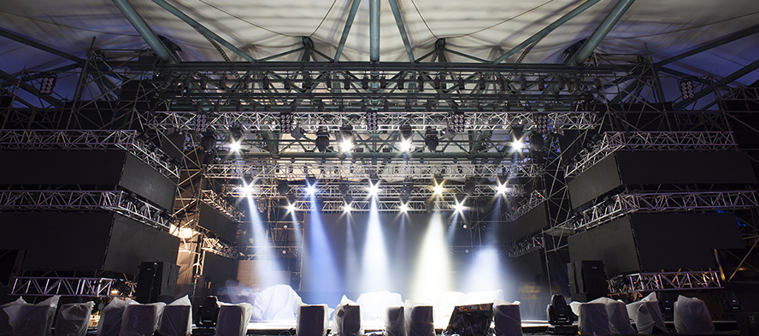
Music Factory  Butch Ardis  (803) 840-5263 | X Factor Productions  Xavier Brunson  (803) 406-5989 | Javon F. Studios  Javon Freeman  (910) 853-4455
Grey Bird Media  Grey Shealey  (803) 968-3445 | G Sound & Lighting  Michael Geter  (803) 236-7552 | Barris Event Services  Barris McWhite  (843) 992-5454
Vision Entertainment LLC  Dante Lewis  (803) 261-8340 | Quietstorm Sound Company  Jazz Harrison  (803) 316-1427 | Total Sound Plus  John Ragin  (803) 464-9953
Natural Sounds Production Co.  Denzell Riley  (843) 513-2608 | Southern Lighting & Sound, LLC  Bernard 'BJ' Brown  (843) 270-3546 | Diamond Music Group  Ray Spann  (803) 633-5121

STAGE CURTAINS (SOFT GOODS):
- Main Drape (Manual Operation)
- Up-Stage Traveler (Black)
- Down-Stage Curtain (Black, Dead-Hung on Rail)
- Cyclorama (White, Up-Stage)
- Scrim (Black, Up Stage, 2 ft. Down-Stage of Cyclorama)
- (8) Legs (Black): (4) Stage Right, (4) Stage Left

BASIC LIGHTING SYSTEM INCLUDES:
- Standard LED Lighting
- Inquire for additional services at cost

BASIC SOUND SYSTEM INCLUDES:
- Stage Monitors
- Front of House Speakers
- (1) Mixing Console
- (4) Microphones (Shure SM-58) and Cables
- (4) Microphone Stands
- Inquire for additional services at cost

EQUIPMENT FEES
ITEM | RATE
Piano, Studio Upright | $250/hr. Tuning Fee
Follow Spots (2 units) | $25 per Rehearsal / Performance
Risers 3/Tier (Must Bring Crew to Assist w/Moving) | $15/ea. per Performance
Folding Table & Chairs – Set (6 ft. and 8 ft.) | $15/ea. per day
Marley Dance Floor | $300 per day

ADDITIONAL TECHNICAL SERVICES

Are you interested in enhancing your theatrical experience? If so, consider our Sound and Lighting Design services. Patriot Hall is committed to helping clients enhance their production by providing Technical Engineering Services for an additional cost of $500. If you would like to purchase additional Technical Engineering Services, please complete the form below.

NAME: _______________________________________________________________________________________________________________
DATE OF PERFORMANCE:_____________________________________________________________________________________________

Please provide detailed information concerning the requested service. The Technical Director will use this information to decide if we are able to provide the services requested.
_____________________________________________________________________________________________________________________________________________________________________________________________________________________________________________________________________________________________________________________________________________________________________________________________________________________________________________________________________________________________________________________________________________________________________________________________________________________________________________________________________________________________________________________________________________________________________________________________________________________________________________________________________________________________________________________________________________________________________________________________________________________________________________________________________________________________________________________________________________________________________________________________________________________________________

SERVICES APPROVED: ☐ YES ☐ NO


EVENT PARKING

Parking is available in the lot bordered by Hasel Street and Mood Avenue (the parking lot between Mood Avenue and Salem Avenue). Overflow parking is available on Purdy Street.

EVENT STAFFING

All Patriot Hall events require Patriot Hall personnel which are compensated by Sumter County Government.

BUILDING OPERATING POLICIES

- Lessee is responsible for restoring the facility, furnishings, equipment, etc. to the same condition in which Lessee received them and assumes full responsibility for damage to or loss of Lessor’s property.
- The Sumter County Cultural Center is a NO SMOKING building. Smoking is permitted only if it is associated with the plot of the production and is confined to the stage.
- Any fraction of an hour constitutes as a full hour charge. All charges associated with damages to the Patriot Hall facility, equipment, furnishings, replacement, repair, cleaning, restoring, etc. resulting from misuse, carelessness, or from failure to provide adequate security personnel will be charged to Lessee.
- No food or drink sales are allowed inside the facility or on the Sumter County Cultural Center grounds. Food and drink are not allowed in the theatre unless it is a part of the production and confined to the stage.
- Do not place stage markings without consulting Patriot Hall staff.
- Contact a Patriot Hall staff member before attempting to affix any decorations to walls, woodwork, ceilings, windows, doors, lighting fixtures, or floors.
- No tables/chairs, displays, or work areas may be in the lobby, passageways, or stairwells that blocks or restricts the path to an exit or in any way that breaks Sumter Fire Department’s Fire and Safety Codes.
- Sound loudness levels of performances shall comply with all local ordinances and be held within the OSHA guidelines for public safety. Sound levels cannot exceed 90 dB (decibels) per seat. Patriot Hall staff will monitor sound levels through each performance.
- Vendor fees are $50/table per event for any merchandise/items sold (flowers, books, T-shirts, etc.).
- Helium balloons are not permitted on the stage or auditorium area. INITIAL HERE __________

SOCIAL MEDIA

Patriot Hall staff may assist in promoting events held in the theatre on social media channels and the Sumter County website. INITIAL HERE __________

GIFTS AND GRATUITIES

Patriot Hall personnel are forbidden to accept any payments, monetary gratuities, or anything worth twenty-five ($25) dollars or more in a day or anything worth two hundred ($200) dollars or more in the aggregate calendar year. INITIAL HERE __________

ADDITIONAL CONSIDERATIONS

Lessee shall defend, indemnify, and hold harmless Lessor, its agents, officials, servants, and/or employees, each separately and jointly, from and against any and all liabilities, demands, claims, damages, losses, costs, and expenses of every kind and description, including, but not by way of limitation, and all direct and indirect costs of defense made against or incurred by such indemnities as a direct or indirect consequence of injury, sickness, or disease, including death, to persons, injury, or destruction of property, including without limitation the loss of such property, and any other cause of action whatsoever arising out of or resulting from, of which would not have occurred or existed but for the existence of this Lease and Agreement. INITIAL HERE __________

An Event Coordinator, along with the lessee, is required to conduct a walkthrough at the conclusion of the event to ensure the facility is clean and without any damage resulting from misuse or carelessness.

I have read, understand, and agree to comply with all policies, rules, deadlines, and rental fees specified in this rental contract.

Signature __________________________________________________ Date _________________________________

Print Name_________________________________________________

